Big Mountain Resort Recommendations and Conclusions

Our goal for this project was to examine Big Mountain Resort’s ticket price based on relevant, comparable factors from other resorts nationwide. After completing an analysis into the data provided by the resort manager, we were able to identify a few key factors (or features) that support an increase in ticket price at Big Mountain Resort. Big Mountain Resort is currently charging $81.00 for an adult weekend ticket. We recommend increasing the ticket price to $95.00 as this price better reflects the premium features Big Mountain Resort offers.

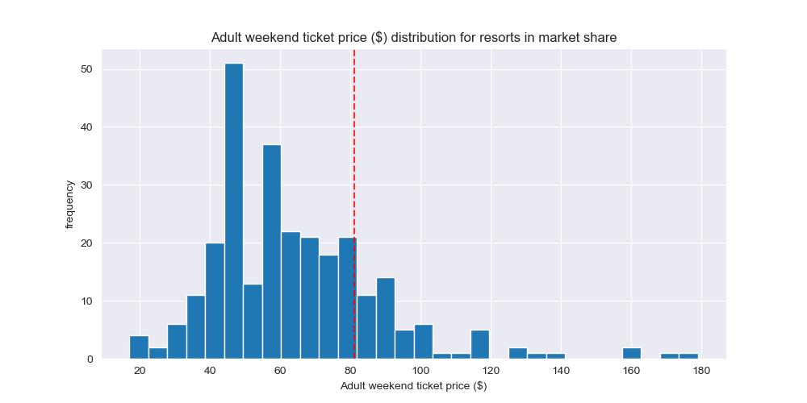

Figure : Adult Weekend Ticket Prices

The data analysis showed that the most important four features contributing to ticket prices were: Fast quads, runs (total number), snow making area, and vertical drop. Fortunately, Big Mountain Resort rates high in these features compared to other resorts nationwide.

Big Mountain Resort’s current adult weekend ticket price is show in figure one as the dashed vertical line. Big Mountain Resort’s pricing is higher than most but there are still several resorts charging significantly higher rates. Therefore, it is important to examine the features that impact ticket prices the most to see where Big Mountain Resort compares.

Big Mountain Resorts features of fast quads, snow making, and number of runs all rank in the upper echelon when compared to resorts nationwide. These features are shown in figures 2-4 with Big Mountain Resort appearing as the dashed vertical line. At the current ticket price, customers are receiving a discount on premium resort features. Therefore, a price increase is supported to match the market rate.

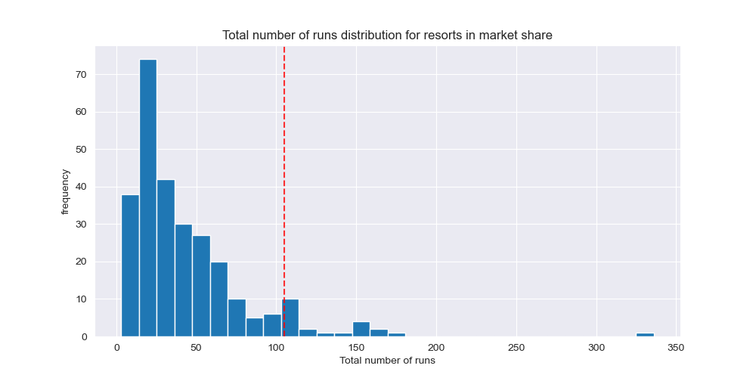

Figures -4 Top: Snow making coverage, Middle: Number of Fast Quads, Bottom: Total number of runs

Additional scenarios were modelled and analyzed to see where Big Mountain Resort could cut operating costs without significantly impacting revenue. The four scenarios were: closing up to 10 runs, increasing vertical drop without additional snow making, increasing vertical drop with additional snow making, and increasing the longest run with added snow making.

Of the four scenarios, we recommend closing five runs. Closing five runs supports about a $0.75 decrease in ticket price while closing a sixth supports a much higher decrease and closing three or four shows no difference. This information is shown in figure five. The other three scenarios did not support revenue producing and cost saving operations.

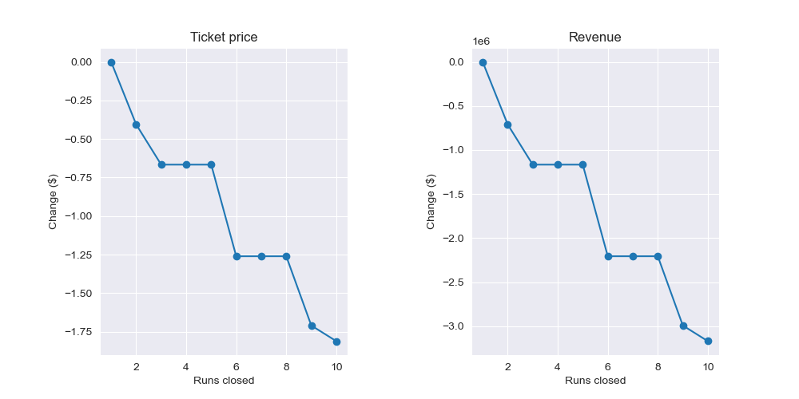

Figure 5: Model of runs closed on ticket price and revnue

In conclusion, given the features Big Mountain Resort offers, we consider Big Mountain Resort to be a premium resort. As such, Big Mountain Resort should be charging a ticket price that is in line with other premium resorts across the country. As a result, we recommend a $14.00 price increase from its current price of $81.00 to a new price of $95.00.